Student Declaration
TECH PULSE FY-26 | AI/ML Capstone Project - Case Study CS1: AI-Powered AUTOSAR HLD Document Analysis Assistant
Student Name | Diksha Vilas Rokade
PRN | 123B1B249
Institute | Pimpri Chinchwad College of Engineering (PCCOE), Pune
Programme / Batch | B.Tech Computer Engineering, 2023-2027

- I declare that the project submitted under CS1 represents my own understanding and contribution, and that I can explain every significant part of the implementation, my implementation decisions, the evaluation results and the limitations of the system.
- I have not changed the approved case-study scope, major methodology or implementation approach without prior faculty approval.
- Only approved or synthetic data has been used. The input documents were generated for this project and contain no confidential or copyrighted third-party content.
- I have verified that the submitted code runs, that the evaluation results in Evaluation_Results/ were produced by the submitted code and configuration, and that the demonstration video shows the submitted version of the system.
- I understand that the submitted version of the project will be evaluated and that any internet or external API dependency has been declared in advance (see External_Dependency_Declaration).
Name and Signature: Diksha Vilas Rokade 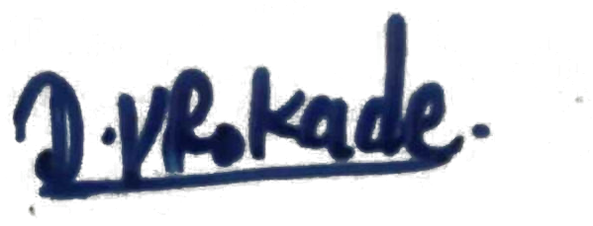 Date: 7-10-2026

